Network Architecture-1

Assignment-2

Name: Vineela Chowdary

Student ID:16208640

(1) **Non Persistent HTTP:**

In this the connection is established between the client and server.

In Non persistent HTTP there are 2 types of connections. They are 1) without parallel connections and 2) with parallel connections

**Non Persistent HTTP without parallel connections:**

Time taken to receive base file = 2RTT0

Time taken to receive each object = 2RTT0

Total number of objects = 9

Therefore time taken for 9 objects = 9(2RTT0) = 18RTT0

So total time taken = 18RTT0+2RTT0 = 20RTT0

**Non Persistent HTTP with parallel connections:**

Time taken to receive base file = 2RTT0

Time taken to receive all the objects in parallel = 2RTT0

Total time taken for 9 objects = 2RTT0+2RTT0 = 4RTT0

**Persistent HTTP:**

In Persistent HTTP there are two types of connections. They are 1) without pipelining connections and 2) with pipelining connections

**Persistent HTTP without pipelining connections:**

Time taken to receive base file = 2RTT0

Time taken to receive each object = RTT0

Total number of objects = 9

Therefore time taken for all the 9 objects= 9RTT0

Therefore total time taken = 9RTT0 + 2RTT0 = 11RTT0

**Persistent HTTP with pipelining :**

Time taken to receive base file= 2RTT0

Time taken to receive all the objects through pipelining = RTT0

Therefore total time taken = 2RTT0 + RTT0 = 3RTT0.

**(2) (a)** The information that should be added for start up company (networkguru.com) is as follows.

Firstly, select the domain name then registration of the name **networkguru.com** at the Domain Name Server Registrar should be done. While registering we have to give the provide names and IP address as these are the primary and secondary sources for a authoritative name server. The domain name should not exist previously.

Secondly, the registrar has to record the name in the TLD( Top Level Domain) server. TDL contains different domains which are arranged in the hierarchal model i.e., .co, .org, .me etc. In the top level of the hierarchal model there are country domains like .in, .uk etc where the registrar has to record the name.

Lastly, the record created by the authoritative user for **networkguru.com** isthe DNS that maps to the IP address. In order to get the email service for the domain name MX type service should be record for the name **networkguru.com.** Email service can also set up.

**(b)** There are numerous companies that can be contact for domain name registration. Some of them are

|  |  |  |
| --- | --- | --- |
| Company | Fees per year | Hyperlinks |
| Namecheap | 9.98$ | http://www.Namecheap.com |
| 1&1 | 4.99$ | http://www.1&1.com |
| Go Daddy.com | 11.99$ | http://www.Go Daddy.com |
| Name.com | 9.99$ | http://www.Name.com |
| Gandi | 16.85$ | http://www.Gandi.com |

For example if we take Name.com the fees is charged as follows:

1) .net - 10.99$/year

2) .US - 10.99$/year

3) .co - 10.99$/year

4) .online - 14.99$/year

5) .sale - 29.99$/year

**(3) Stateful Protocol:**

Stateful protocol is a protocol which requires or modifies some state of the system i.e., stateful server is aware of the previous requests of the user. The server remembers the activities of client.

A stateful system is similar to static machine with memory. Here the output can be generated depending on the input and previous input values.

**Examples**: Telnet, TCP and FTP are the examples of Stateful Protocol

**Pros**:

* It maintains the state of the system
* It can communicate with any system outside the protected network
* It preserves the context of relationship and has the ability to anticipate dynamically the assigned port numbers
* Data is stored in the memory that is non persistent

**Cons**:

* Stateful classification is more complex
* Implementing Stateful classification consumes more power and the system costs are high
* Large memory is required
* Time delay occurs from the client when it is communicating with other client

**Laboratory Homework**

**Part-1: Telnet Experiments**

**HTTP Request GET**:

For Google.com

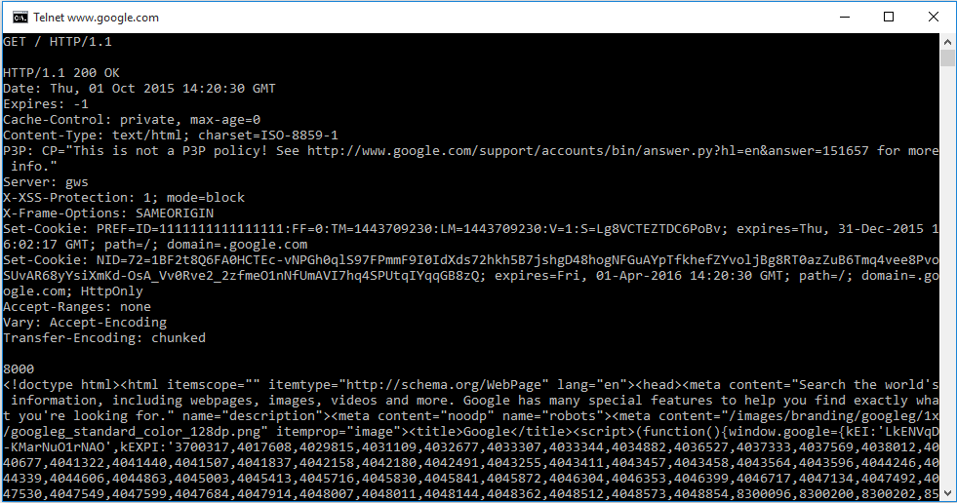

For Google Maps.com

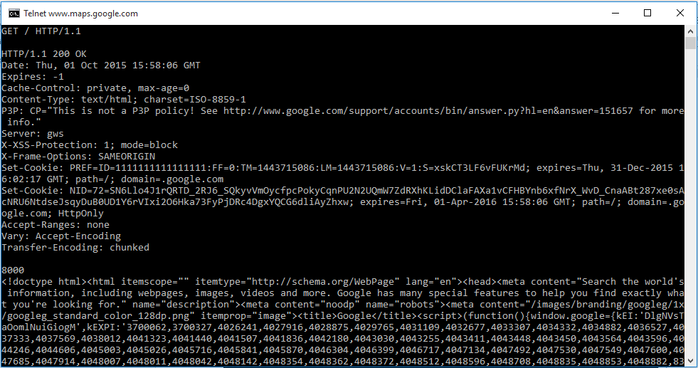

For amazon.com

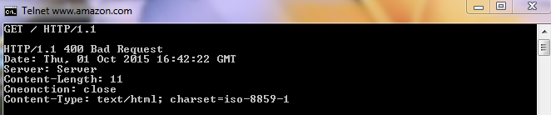

**HTTP Request Head**:

For Google.com

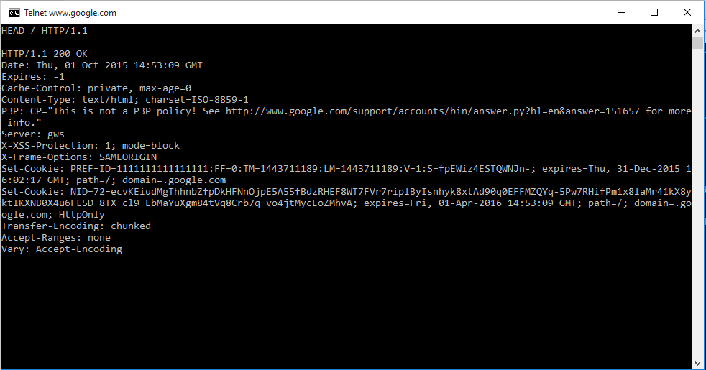

For Google Maps.com

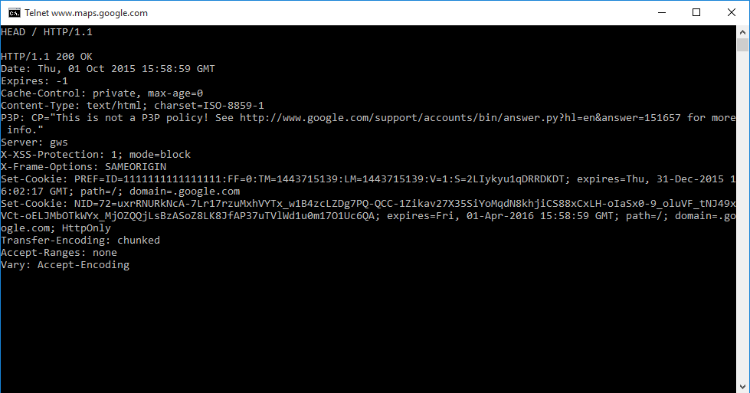

For amazon.com

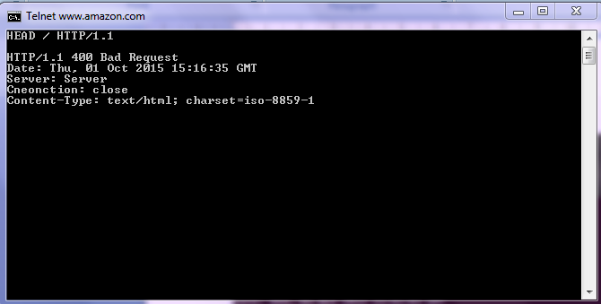

**HTTP Request Post**:

For Google.com

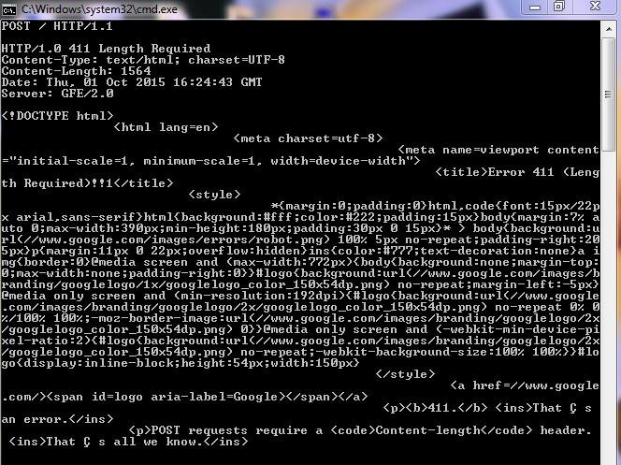

For Google Maps.com

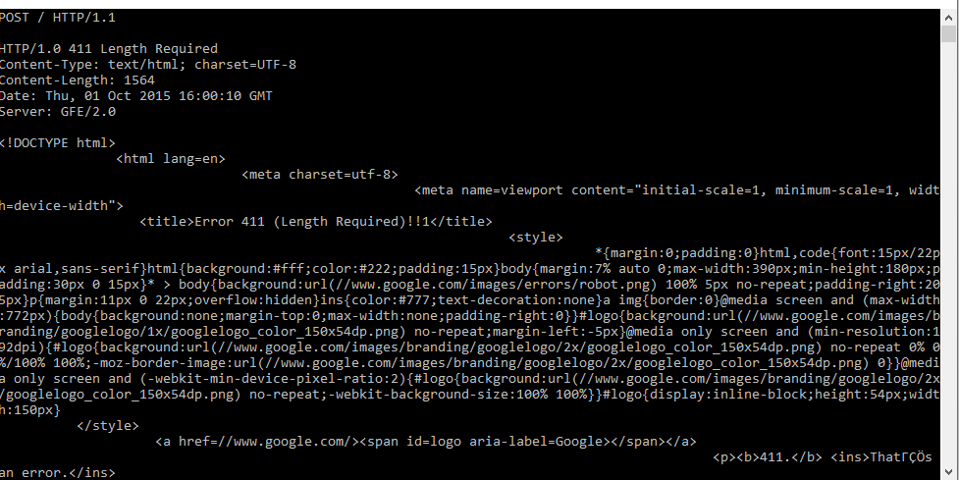

**Part-2**: **Wireshark Experiments**

**1)** HTTP Version is 1.1

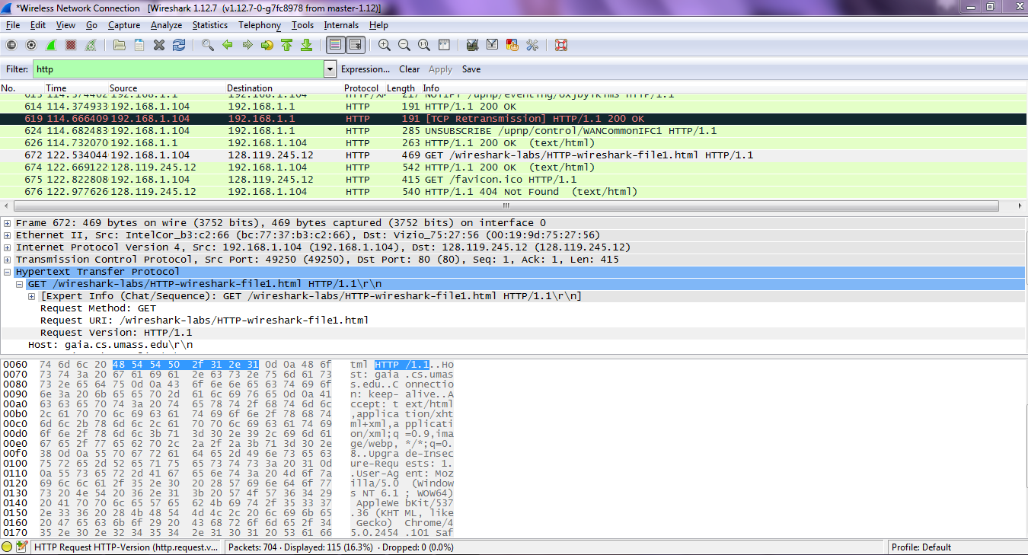

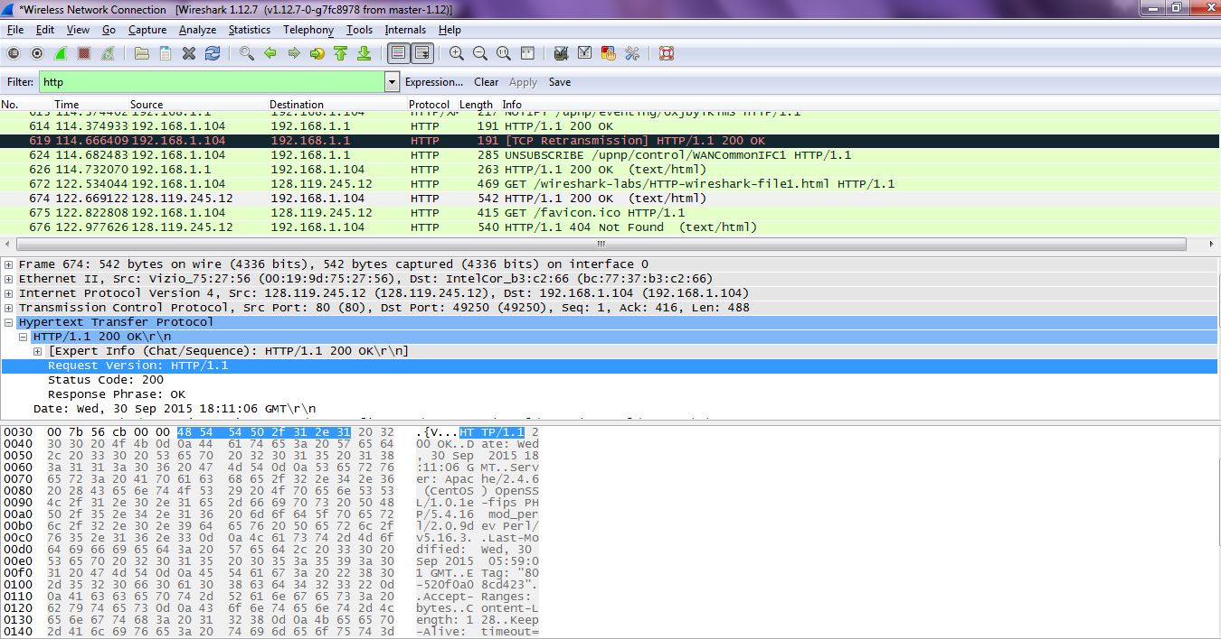

2) Languages: en-US,en;q=0.8,r\n

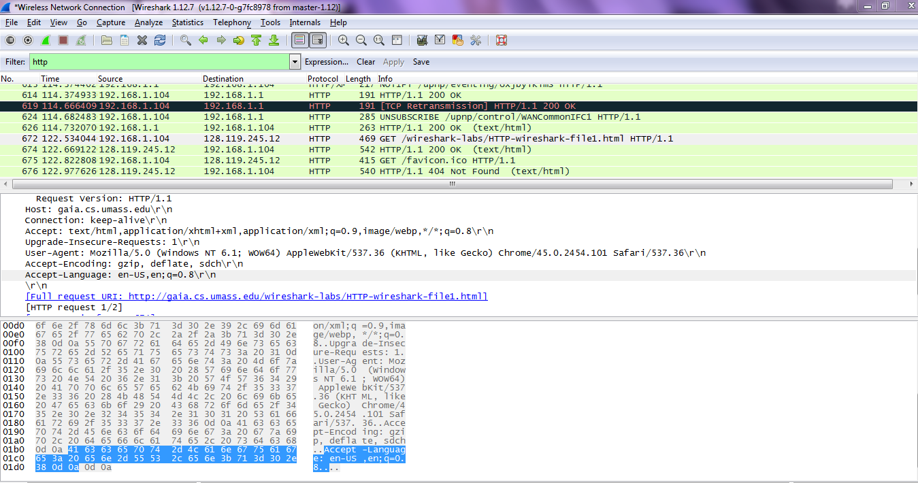

3) IP address of computer

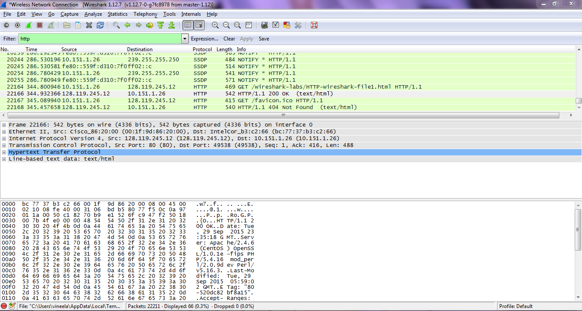

4) Status code: 200

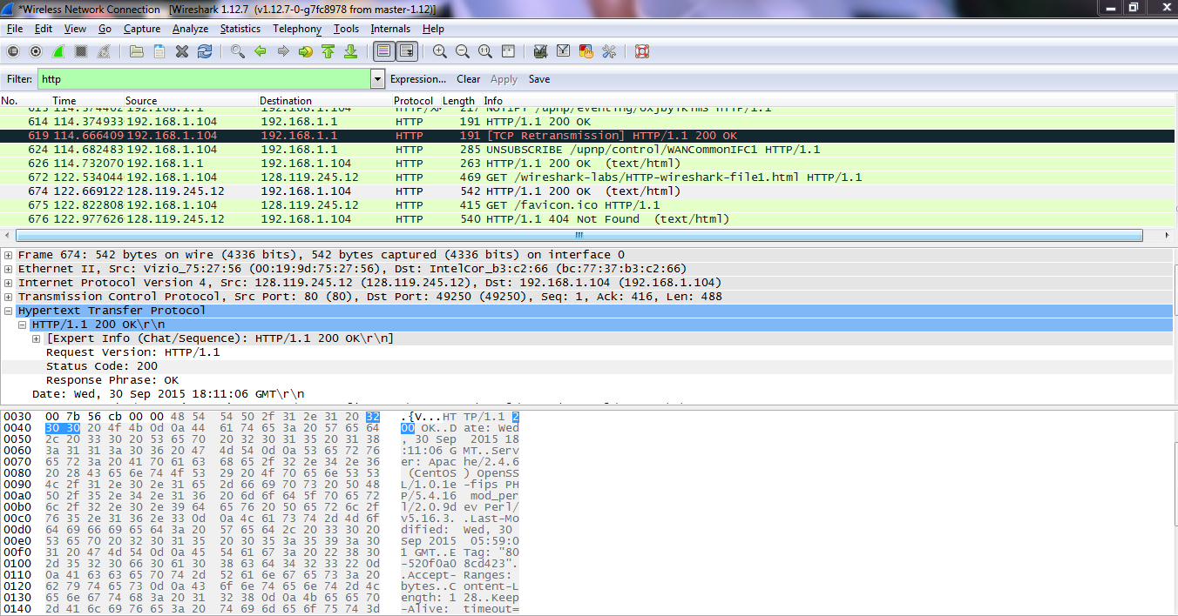

5) HTML File retrieved: Wed,30 sep 2015 18:23:55 GMT\r\n

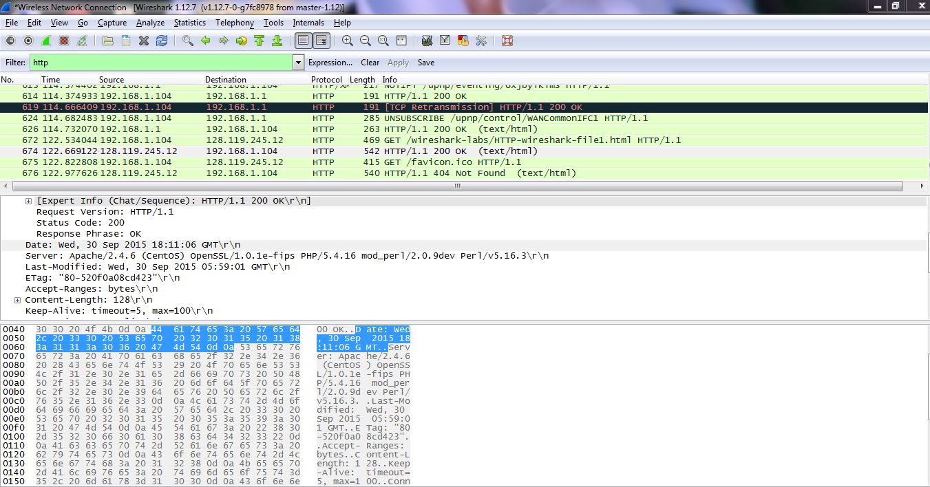

6) Bytes of content: 128

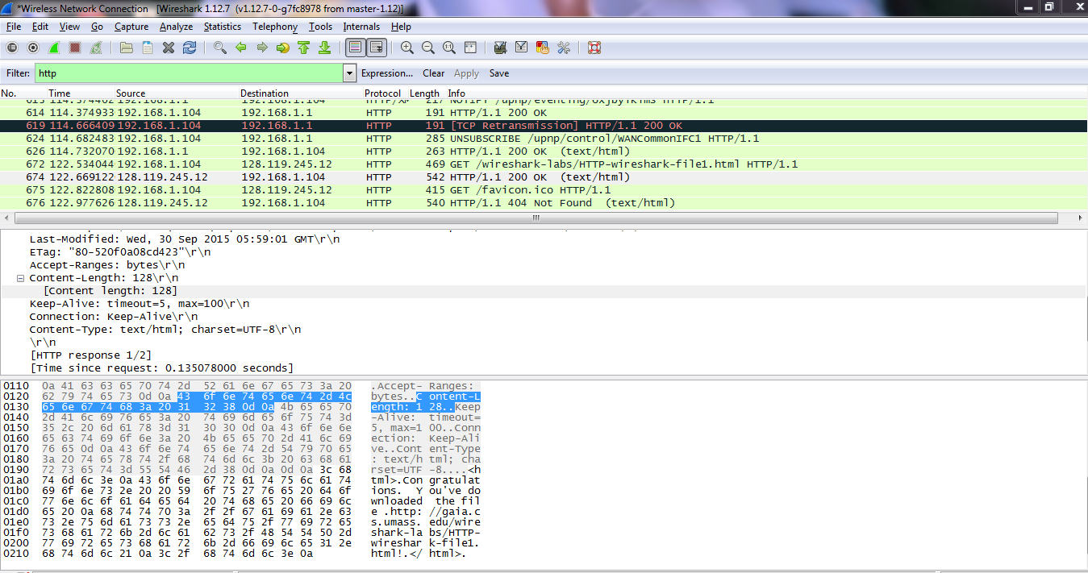

**Part 2-2**:

1) HTTP get requests: get

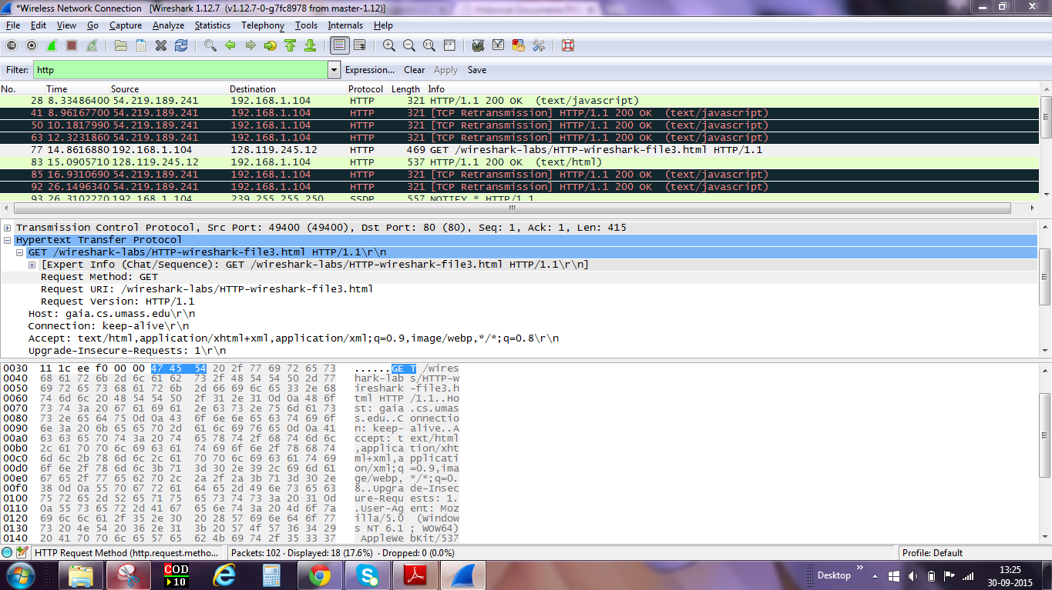

2) TCP segments

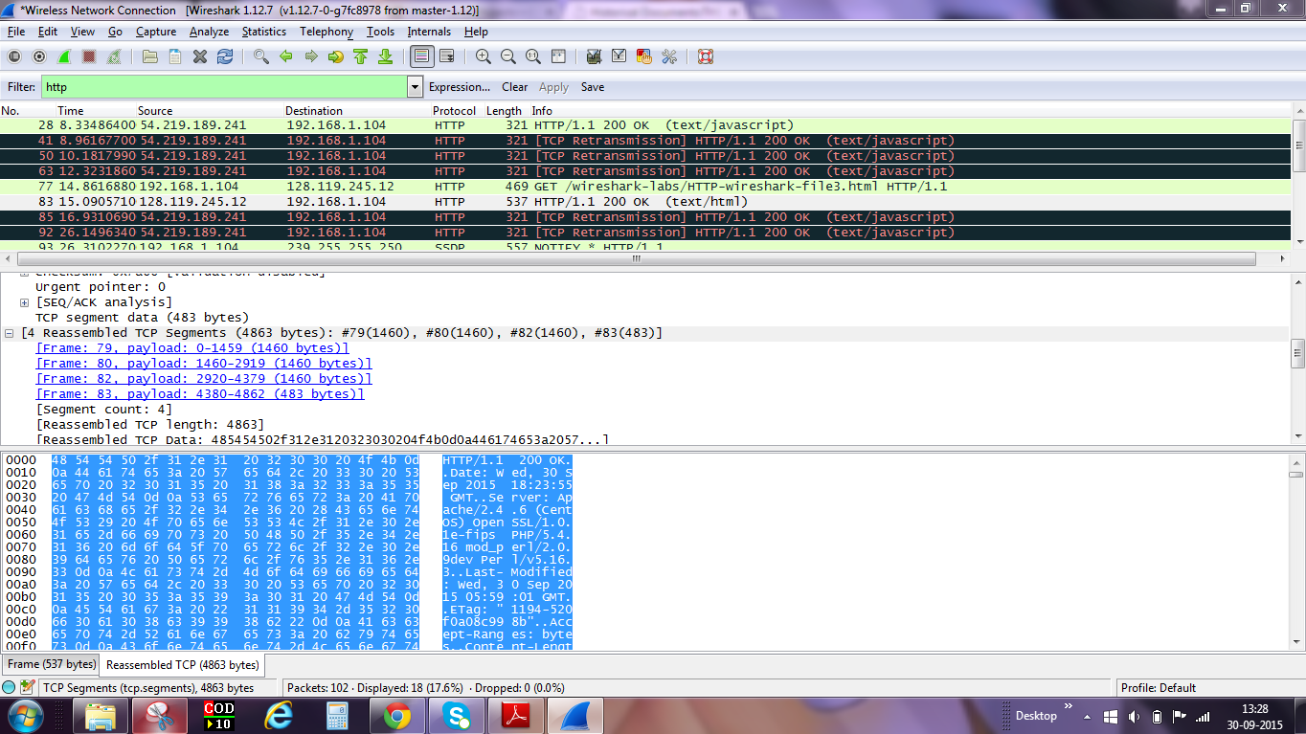

3) Status Code and Phrase: 200

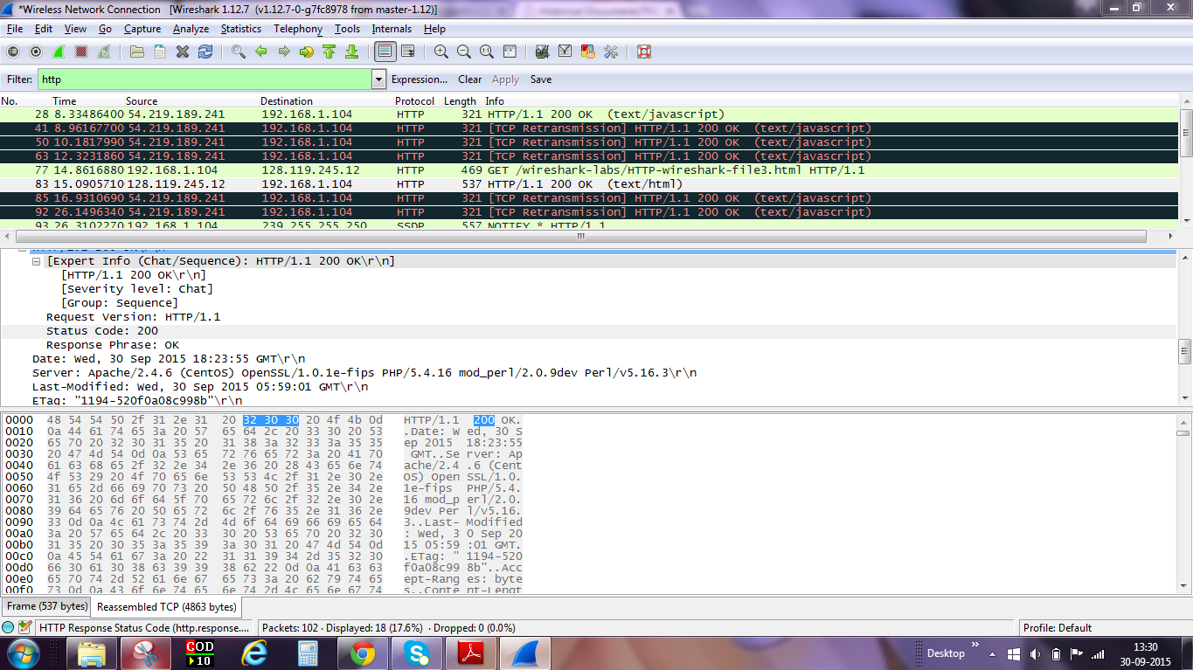

4) **No**

No HTTP status lines in the transmitted data are associated with a TCP induced "Connection".

